Attendance Reflection – First Iteration
Project: ARTNEST – Personal Museum Memory & Wishlist
Course: IN-SDE-EN-CMK
Student: Anita Ivanova
Table of Contents
Attendance Reflection – First Iteration 1
1. Purpose of this document 1
2. Attendance overview 1
3. Single absence 2
4. Reflection and commitment 2

1. Purpose of this document
This short reflection gives context to my attendance record during the first iteration of my individual project. Since this period only covers the first 16 days, the document is kept brief and focuses on the one absence shown in the attendance overview.

2. Attendance overview
During this first iteration, my attendance record shows a total of 16 days, with 15 present days, 0 late days, and 1 absent day. This results in a current attendance score of 94%. Overall, my attendance during this period has been consistent.
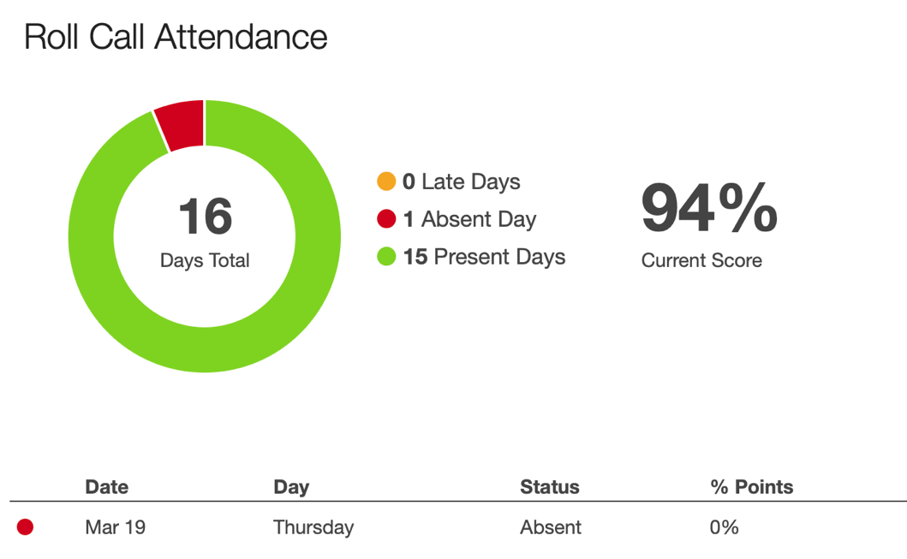

3. Single absence
There is one registered absent day in this first iteration. This happened because I had a flight that had been booked earlier, before I was aware that the first meeting with the clients would take place on that day. Unfortunately, this meant that I missed that meeting.
Even though I could not attend in person, I communicated with my team afterward so that I could fully understand what had been discussed and what the next steps were. This helped me stay informed and continue my work without losing track of the project direction.

4. Reflection and commitment
Although there was one absence, I made sure to stay involved in the project by communicating with my team and keeping up with the work. This situation also made me realize that I need to be more careful in the future when planning travel, especially during project periods when meetings can be scheduled.
Going forward, I want to continue being present and involved, while also planning more carefully to avoid similar situations.

